Faith, Luis, Sam

To The Moon

Fall 2021

Butter Melt

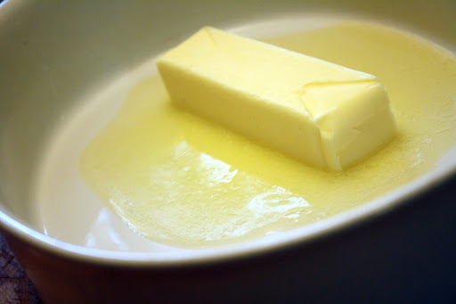

# About the game

In this game, the player must either stop a stick of butter from melting or cause it to melt. The player will be hit with various obstacles that prevent the goal from being reached. To combat these obstacles the player must use items. These items can be bought through an in-game currency that the player earns the longer they keep the butter at the desired state. This is heavily inspired by both Plants Vs. Zombies and Mario Party.

## Why Mobile

This game is a great design for mobile because it is a very simple, laid-back game. The player can easily start playing at any time and leave whenever they want. The story is also quite loose that doesn’t require a very large time investment to follow. This makes it perfect as a mobile game.

Scenario

There is to be a birthday on the moon that they need to make a cake for. The butter is a necessary ingredient but was forgot on Earth. So thus, the Butter Program is born. The only issues are that the butter is in unstable and needs to be kept at the perfect temperature. The player plays as an esteemed baker that must keep the butter safe.

## Genre

Butter melt is an arcade food game. This game is about trying to keep a stick of butter (as well as other items traditionally kept cold) from melting on a hot summer day for as long as possible.

## Target Audience

The target audience for this game are people who enjoy idle type games. It is mainly meant for kids in the age range of 12 – 16. This game is meant to be causally played by people who need to kill a couple minutes of time.

References

Plants v Zombies inspired our progression system and difficulty curve. One example of our progression inspired by Plants vs. Zombies. Their shop involves gaining suns and spending them on defenses against the incoming zombies. We are implementing a similar system by having the player collect Doge coin to get items to help the player get to the Moon and save the day!

Mario Party also inspired the idea of butter melt through its mini-games. In Mario Party, there are thousands of mini-games that can be played by a user(s) as to determine if they won or not. Butter Melt is supposed to be similar to one of those mini-games but is intended to be played on mobile devices only.

## Key features & Mechanics

The player must use items to either stop a stick of butter from melting or cause it to melt. The player will gain coins the longer the butter is kept alive. These coins will allow the player to purchase items to make keeping the butter alive easier. These items can include a fan, wind, ice storm, snow, lower temperature, heat wave, hot breeze, heater, oven, or fire.

# Game Mechanics and Dynamic

## Concept Art

Menu Screen Background Options Main Screen Credits

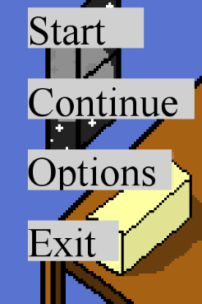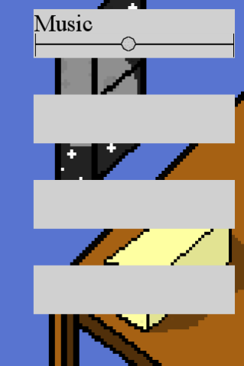

How to play Lab Rocket

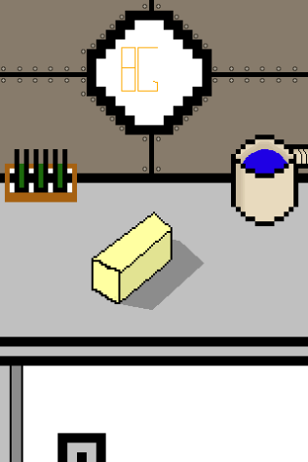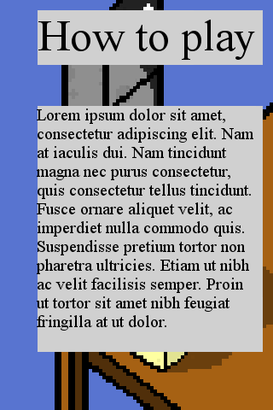

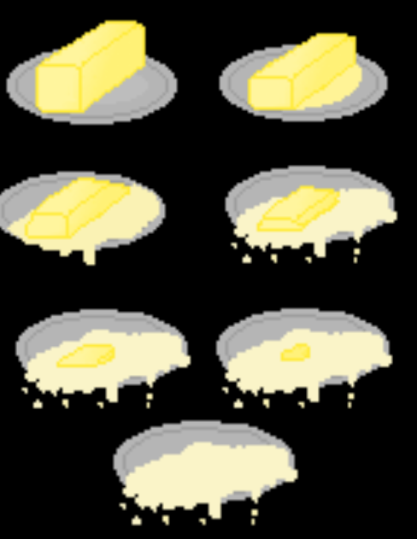The Butter Melting Stages



Leaving Earth Orbiting Earth Deep Space Landing on Moon

## Game Mechanics

The player uses items to make sure that the butter stays in the perfect temperature range. This range will start as a big amount and get smaller the higher the level. While in this range, the player will be appointed points that they can use to buy items that helps keep it at the perfect temperature. Inside of this range, there is also the perfect temperature. If the player gets the butter to be at that perfect temperature, they will get awarded double the number of points. The game will cause the temperature to fluctuate due to outside events. These outside events will also get harder as the game goes on. It could range from easy, medium, or hard events that will cause the temperature to change. If the player lets the butter get to temperatures outside of the range, the player will start losing lives. They lose a life for every 5 seconds that the butter is outside of the perfect range.

## Scoring System and Achievements

The player will get points by keeping the butter in the perfect temperature range. There is a range of the perfect temperature that awards the player a certain number of points. There is also the perfect temperature. If the player keeps the butter at the perfect temperature, they get double the number of points. The goal is to get the greatest number of points and keep the butter alive till the time runs out.

## Interface

This game will involve touch gesturing. The player will be able to touch the screen to help keep the butter warm/cool. They will also touch to purchase and place items to help aid the player to get the perfect temperature.

## Game Flow

## Diagram Description automatically generatedScreen Flow

# Tech

## Tech Aspects

This game will use touch sensors to know when a player touches the screen for various events such as purchasing and placing items.

## Resources

Our group will write all the code in Lua. Our group will also utilize Gimp for a better GUI. Solar 2D will be utilized to test and debug the Lua code that we created. GitHub will also be used to keep track of all the team members’ progress and stay organized.

## Game Assets

We are using GIMP to make Sprites for the game. We will also be using bfxr to create sound effects for the game. We will also include background music that we will find online to add to the experience of the game.

## Camera Information

Isometric camera, 3D thanks to the drawing, but not in programming.

## Schedule

|  |  |  |
| --- | --- | --- |
| Date | Assignment | Member Name |
| 10/19 | Proposal Guide | Luis, Sam, and Faith |
| 10/19 | Presentation | Luis, Sam, and Faith |
| 10/26 | Work on Sprites | Luis, Sam, and Faith |
| 11/2 | Start Programing Screens | Luis, Sam, and Faith |
| 11/9 | Work on implementing game | Luis, Sam, and Faith |
| 11/16 | Continue work on implementing game | Luis, Sam, and Faith |
| 11/23 | Work on GUI | Luis, Sam, and Faith |
| 11/30 | Begin Testing and Final Touches | Luis, Sam, and Faith |